

Feed forward multilayer neural network

XOR with backpropagation

Handwritten digits recognition

Handwritten alphabet recognition



Sri sai vijaya aditya nittala

Roll number: 177163

REGISTRATION NUMBER: 841775

The architecture of a 3-layer Neural Network is shown below:

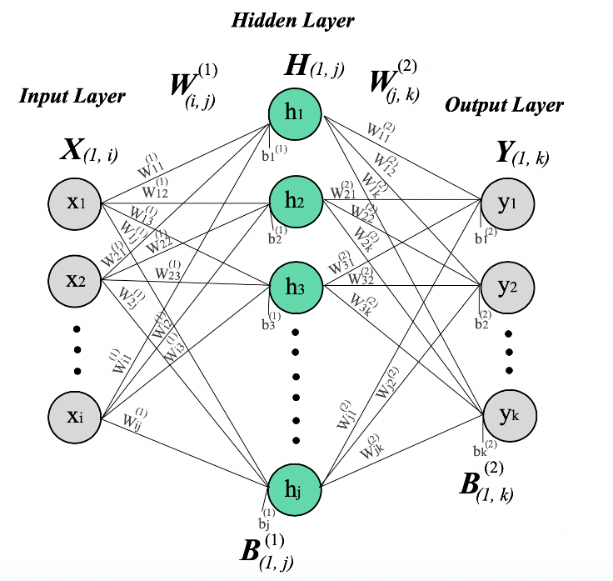

Where,

* X: Input features fed into the Neural Network.
* W: Weights associated with the activations of the Neural Network.
* B: Bias term introduced to the Neural Network.

A Neural Network can be used for classification purposes. The algorithm that is used to classify is called ***Backpropagation.*** An overview is given below:

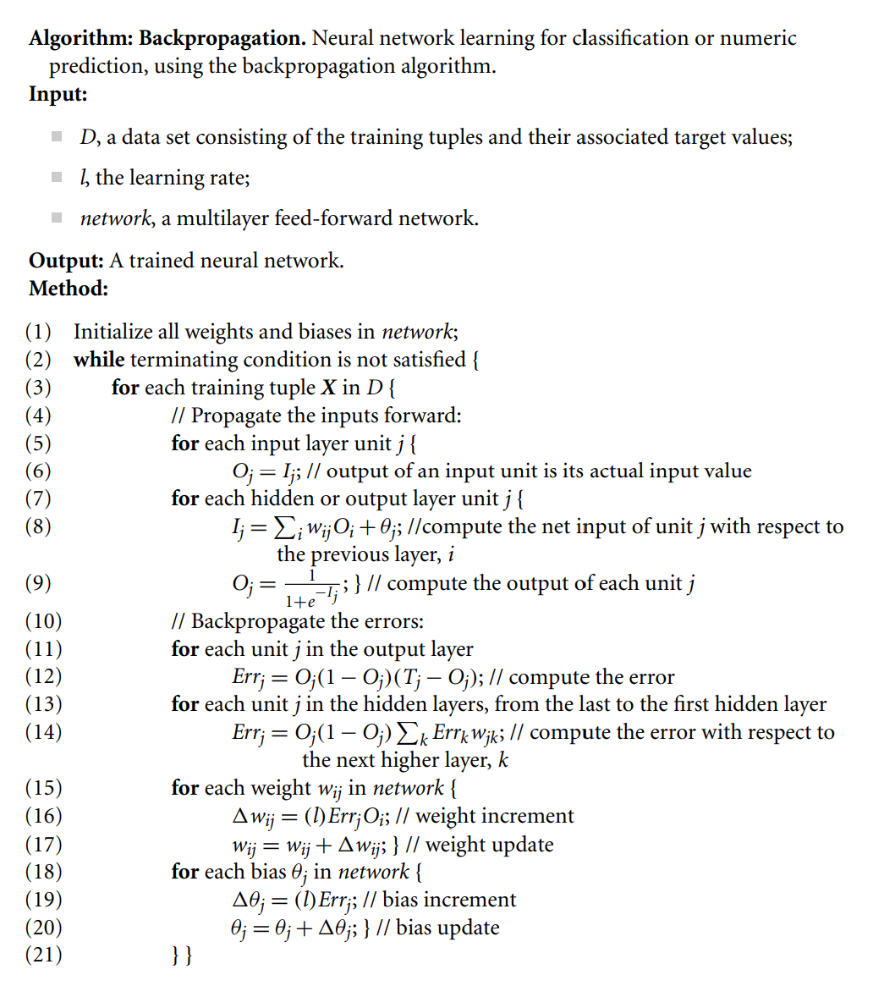

In this assignment, using the ***backpropagation*** algorithm, the following have been implemented:

1. **Exclusive OR (XOR) gate implementation:**

The truth-table of an XOR gate is given below:

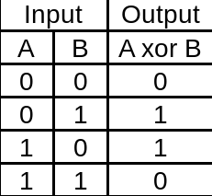

**Information about the implementation:**

* 1. Number of neurons in input layer: 2
  2. Number of hidden layers: 1
  3. Number of neurons in the hidden layer: 2
  4. Number of neurons in output layer: 1
  5. Input: Dataset is essentially the truth-table of XOR but 0s are represented by 0.1 and 1s with 0.9 as sigmoid cannot compute exactly 0 or 1.
  6. Number of iterations: 1000
  7. Learning rate: 0.1
  8. Weights are update after each forward-backward pass, i.e, not a batch update.
  9. Test data: truth-table of XOR

1. **Handwritten Digit recognition:**

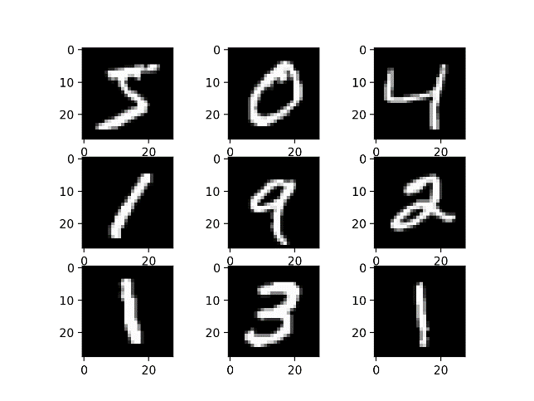

The dataset used for this application is the **MNIST** dataset. It consists of images, each of size **28x28** pixels (total 784 per image). Number of training and testing examples taken is less due to infrastructure constraints. Code attached at the end contains more information about the input.

**Information about the implementation:**

1. Number of neurons in input layer: 784
2. Number of hidden layers: 1
3. Number of neurons in hidden layer: 50
4. Number of neurons in output layer: 10
5. Input:
   1. Number of training examples considered: 1000
   2. Number of testing examples considered: 100
6. Learning rate: 0.01
7. Number of iterations: 10
8. **Handwritten alphabet recognition:**

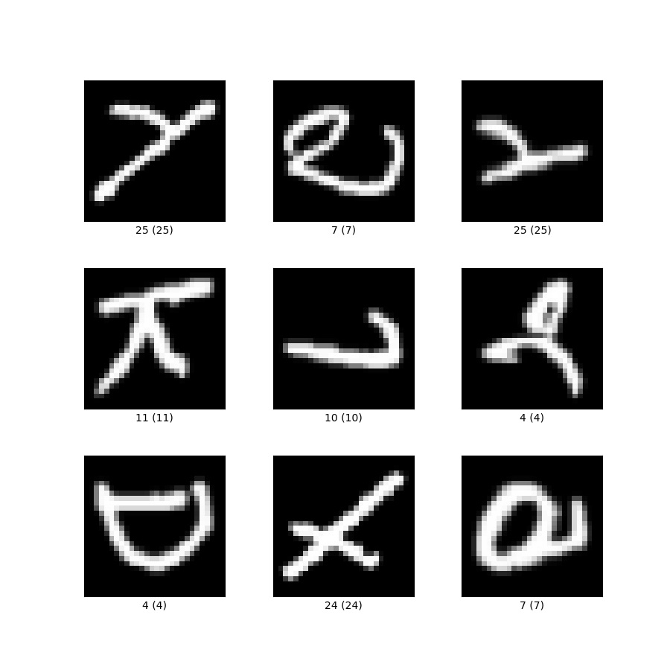

The dataset used for this application is the **EMNIST** dataset. It is very similar to the previously described MNIST dataset. Contains images of size **28x28**, total of 784 pixels. More information is provided as comments in the code attached below.

**Information about the implementation:**

1. Number of neurons in input layer: 784
2. Number of hidden layers: 1
3. Number of neurons in hidden layer: 50
4. Number of neurons in output layer: 26
5. Input:
   1. Number of training examples considered: 2400
   2. Number of testing examples considered: 600
6. Learning rate: 0.01
7. Number of iterations: 10